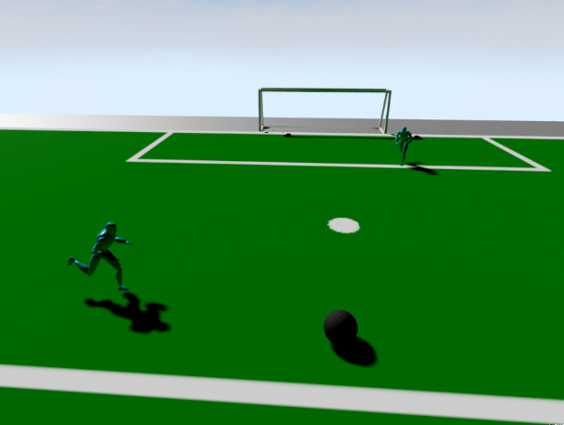Imagine Cup

Project Blueprint Challenge

Games

|  |  |
| --- | --- |
| **Team Name** | UnrealCup |
| **Country** | Germany |
| **Project Name** | UnrealCup |

First prototype

# Concept

Our project “UnrealCup” is quite a different approach on Football games. Instead of controlling your team directly, you can give each player a certain pattern which describes how the player will act. Like in real football there will be 11 players competing in 2 teams against each other. All common football rules will be considered and the players will be punished if they break the rules. The game will feature a 3d playing field and animated players. The movement of the ball will be computed by using the game engine’s physic engine. The game will be available for PC and Xbox One.

There will be 3 approaches for creating your own player intelligence:

## Macro recording

If you never encountered any programming this is the first approach for you. In this editor you can move you players yourself and record patterns for certain situations. This way you can control how your players will behave, without knowing logic happens in the background.

After you created a recording you can use it in the graphical editor. If it is not good enough you can enhance it even further by directly editing the file.

## Graphical Editor

If you already have a grasp how logic in programming languages work you can use a graphical editor to define your own logic. In this editor you can create your logic by dragging predefined parts together. This way you can create complex decision trees or loops without actually code a single line.

This approach is best suited for users which already have a glue how logic programming works, but not capable of coding their own logic. Since this Editor is all about drag and drop a version for windows tablets would be possible.

## Coding

This approach is for all the hardcore users out there, who might feel limited by the previously mentioned tools. You can create your own logic files by editing the outcome of the previous tools or even create it from scratch. For this purpose you have to use the scripting language “LUA”, in which predefined actions like “move” or “turn” can be triggered. All possible actions will be documented.

The game main focus is not to create a casual game, but to create a game which helps the players to learn something about logic and programming in a fun way.

# Target Audience

Explain who your audience is. Consider targeted platforms, geography, and demographics. If you can estimate the size of your target audience please do so and cite your source for the estimated data.

* Schüler, Studenten
* Vorlesungunterstützung
* Als Basis für Logikinteressierte
* Junge, technikaffine Leute
* Strategie Spieler
  + “Die perfekte KI entwickeln”
  + “Perfektionisten”

# Personas

## John Smartman

A typical user for our project is John Smartman, he is a 16 year old sixth former at a German school. He likes to work with computers and he even tried to write some computer program before. So he decided to go to a special school with Computer Science as main course. In one of his first Computer Science courses his teacher wants so explain the logic of computer programs. For this purpose the teacher used UnrealCup to show the principals of computer logic. He explains how the decisions of the robots are defined by logic in their AI. John was so fascinated by this and downloaded UnrealCup to his own computer and took a better look at it. After a few days playing with the editor he began to program his own AI. After working with UnrealCup he got really fascinated by software development and decided to study Computer Science.

## Jack Hardcore

The second typical person is Jack Hardcore, he is quite the opposite of John. He is a 20 year old student and likes to play games. He is a perfectionist in his games, he does not quit before he gets the best solution for a problem or win the game with the highest possible score. After he discovered UnrealCup he tries to create a very good AI in the editor but he does not win against all the competition. So he needs to get a better AI. The only possibility is to program it on his own. So he learns how to do that. As he worked on the AI he begins to like to program software. So he tries to write his own little game. That is how he became an independent game developer.

# Game Mechanics

## The simulator

The main part of the Game will be the simulator. The simulator will load the specified teams and let them compete against each other. To make sure everything is fair, the simulator will checks the common soccer rules[1].

## The editor

* Fußball Regeln
  + Unreal Engine
* 2 Teams
  + Logik Spielerweise in LUA Skript
  + Aufstellung via XML
* Grafische Ausgabe und Physik Unreal Engine
* Im Simulationsmodus kann ein Spieler ausgewählt werden und Makros aufgezeichnet warden oder eine KI über z.B. Deep Learneing, Neuronale Netze trainieren.
* Editor
  + Basierend auf HTML/JS
  + Grafisch!
  + Drag and drop

# Top User Stories

Write up the 3-5 most important user stories for your project. This can be epics or implementation-level user stories. For each one include the title and your intended confirmations.

* Leicht zu bedienender Editor
* Gute Grafik, echte Regeln,… JACK
* Es soll nicht zu leicht sein, er will eine Herasuforderung, er will in seinen Möglichkeiten nicht eingeschränkt warden… Selbst Programmieren
* Einfach mal kurz etwas spaß haben

# Competition

What other games will you directly compete with for your audience? How do you expect to differentiate your project from your competitors? What elements from competing games have you included in your design?

* RoboCup
  + Reinarbeiten….viel Programmierkenntnisse
  + Wir haben einen grafischen Editor 🡪 Klicki bunti
  + Wir haben eine bessere Platformunabhängigkeit
  + Wir haben die neuere Engine
    - Grafik
    - Physik
* KEIN Fifa/PES
  + Fifa ist ein aktives Spiel
  + Wir sind eher das Denkspiel
  + Zielgruppe nur kleine Schnittmenge

# Business Model

How will your project make money? If it provides an ongoing service, how will that service be sustainable? If there are critical partnerships you must make for your business model to work, describe those here as well.

* LIzensen an Bildungseinrichtungen verkaufen
  + Schüler/Student am Ende kostenlos
* Wenn die Bildungseinrichtung nicht mit macht, gibt es auch Einzellizensen
* Wie Machen wir die BIldungseinrichtungen auf uns Aufmerksam?
  + Abgespeckte Gratis Version?
  + Privat kostenlos, nur BIldungseinrichtungen zahlen?
  + Komfortoptionen kostenpflichtig?
  + Free2Play? 🡪 Marketplace für Editorpakete
    - Optisch: Animationen, Skins…
    - Neue Aktionen
* Komplett Frei?
  + Werbeeinblendungen?
  + Bannerwerbung wie im echten Fußball

# Core Technologies

This includes your key platform(s) as well as specific technologies such as the Kinect SDK, the Unity game engine, or other elements that you believe will be critical to your project’s success.

* UnrealEngine
* LUA
* Editor: HTML/JS

1. http://www.fifa.com/mm/document/footballdevelopment/refereeing/02/36/01/11/27_06_2014_new--lawsofthegameweben_neutral.pdf